Verify Check  Cab  Cleanliness  Seat condition OK  Operator restraint provided  Instruments operational & labeled  Levers / controls operational  Pedals in good condition  ROPS to AS 2294  Windows / wipers / washers  Rear view mirrors  Operator instruction  (available on plant)  Warning devices  Verify Check  Horn  Amber flashing beacon < 12T  Reversing alarm  Verify Check  Warning signs (in cabin)  SEAT BELTS MUST BE WORN  Verify Check  DANGER – BEWARE OVERHEAD WIRES  & UNDERGROUND SERVICES | Supplier verification & Plant details
 | Plant owner:
 | Address:
 | City/Suburb:
 | Phone:
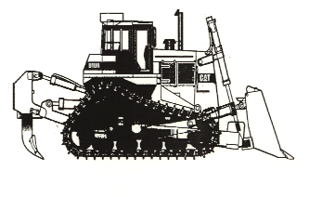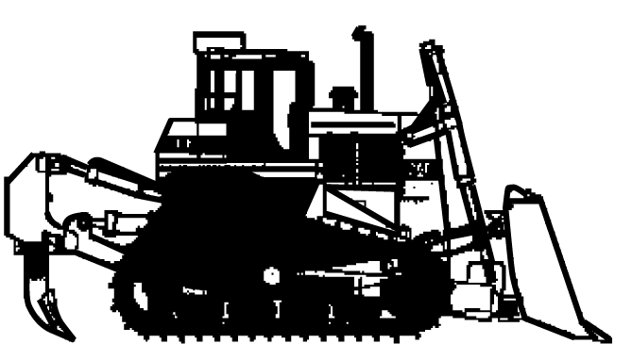 | Plant make:
Verify Check  Rams  Hoses  Connections  (check for excessive wear,  leaks and creep)  Verify Check  Exhaust | Plant model:
 | Serial no.:
Verify Check  Engine guarding | Signature:
 | Date:
 | Work Cover Certification - LZ
 Plant to conform to manufacturer’s specifications and Plant Regulations.
 Plant operator is to provide daily checksheets to WDA on a weekly basis.
 Where applicable, Personal Protective Equipment must be worn.
 Plant Log Book detailing service history in accordance with Manufacturer’s specifications should be written legibly in English.
 Contractor must produce proof of competence of operator, e.g., Certificate of Competence, Licence, detailed Log Book
 | WDA use only
Verify Check  Pivots  Pins  Connections  Safety pins  Verify Check  Tracks complete  Idlers adjusted  Drivers free from leaks  Tracks  Verify Check  Handrails  Steps | Note: Sign only when all items have been checked
 | Plant check by:
Instructions:  Verify Box to be ticked by Owner / Supplier / Operator prior to arrival onsite.  Check Box to be ticked after visual inspection by WDA | Position:
 | Date: |  | / /

